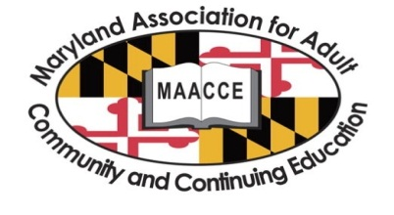

2016 MAACCE Annual Conference
Exhibitor Reservation Form

I wish to reserve exhibit space at the MAACCE Conference at The Conference Center at the Maritime Institute in Linthicum Heights, Maryland, May 12th and 13th, 2016.

Number of tables: ($280 per table) Electricity required: □ Yes □ No
Company:
Website:
Representative(s) attending:
Telephone: Email:
Please check the days you will join us for lunch. □ May 12 □ May 13
Additional representatives: (cost $50 per day). □ May 12 □ May 13 Total:
I wish to purchase advertising space in the conference program:
□ Full page, $125
□ Half page, $75
□ Quarter page, $50
□ Inside front cover page, $160
□ Inside back cover page, $160

Please submit digital files for all ads. Preferred format is PDF. Make sure PDF is Print/Press Quality (high resolution) and all fonts are embedded 100%. E-mail your ad to maacce@gmail.com.

Sponsorship Level: Gold ($3000) _____ Silver ($2000) _____ Bronze ($1000) _____ Copper ($500) _____

Total amount enclosed:
Table:
Additional Representative:
Advertising:
Sponsorship:
GRAND TOTAL

Please return this form by April 15, 2016 to: MAACCE, Attn: Program Coordinator, PO Box 709, Leonardtown, MD 20650

You may set up on Thursday morning after 6:30 am. If the space is available, you will be able to set up after 5 pm on May 11. If you need multiple electrical outlets, please bring your own power strip. If you have any questions or suggestions, please contact Shelley Alter at 443-412-2054 or salter@harford.edu

692 Maritime Boulevard
Linthicum Heights, MD 21090
Telephone: (410) 859-5700 Sales Fax: (410) 859-2893
Website: www.ccmit.org

