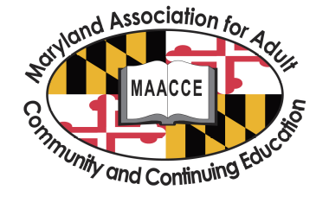MAACCE Membership Application

Advocating on behalf of professional adult, community and continuing education groups and individuals in Maryland, and encouraging organizations and agencies to cooperate in educational programs and activities in support of lifelong learning.
Anyone interested in advancing education as a lifelong process is invited to join.

Date: Membership Type: □ New □ Renewal

Name:
Organization:
Position:
Address:
City: _____________________ State: _____________ ZIP _________
Phone: Email:

Please indicate up to two Interest Groups:

□ Administration [AD] □ Family Literacy [FL]
□ Adult Secondary Education [AE] □ Basic Skills/Literacy [L]
□ Correctional Education [CE] □ Workforce [M]
□ ESOL [E]

Are you interested in participating in one of the following committees?

□ Organizational Structure □ Communications and Advocacy
□ Outreach and Recruitment □ Professional Development

Annual Membership Dues: $ 40.00
Additional contribution: $
Total enclosed: $

□ Paypal □ Check □ Money order □ Agency check - #

Your membership is good for one year, and will expire the following year on the day prior to your renewal date.

Does your Membership Application include a Conference Registration? □Yes □No  

Write checks to “MAACCE” and mail application and payment to:

MAACCE Membership,
P.O. Box 22379, Baltimore, MD 21203

