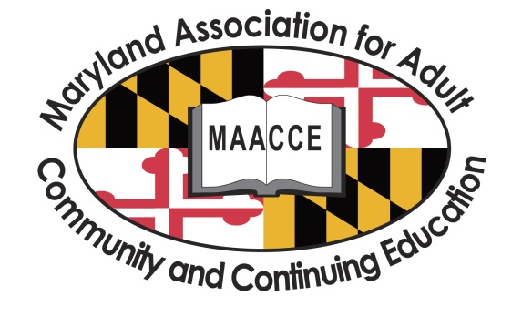
National Adult Education and Family Literacy Week 2018
Mini-Toolkit

Our activities during AEFL Week will be a part of our support for the Educate and Elevate Campaign, spearheaded by the Coalition on Adult Basic Education (COABE) and the National Association for State Directors of Adult Education.

Each of you has stories about how your program made a difference in people getting jobs or job training for a new career. This mini-toolkit emphasizes this theme and provides suggested activities. Please do not feel like you must do every activity; choose 3-4 that are right for you!

If you choose to do just one thing, please ask learners, staff, and other supporters to contact their congressional representatives by visiting www.educateandelevate.org and following the instructions to send an email to their congressional representative!

Please see the next page for Our Call to Action!

TIPS FOR USING
GO GREEN WRISTBANDS
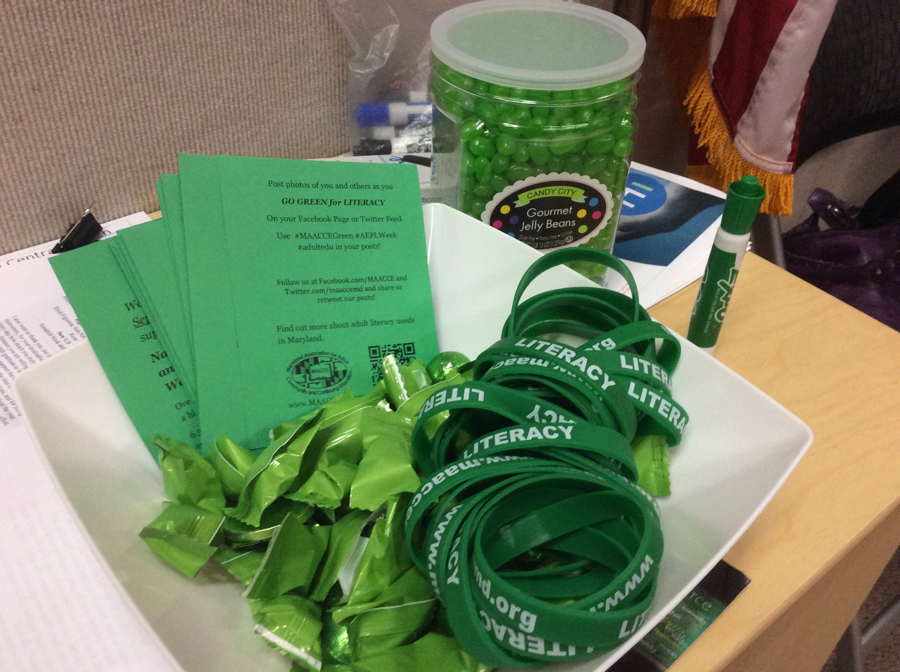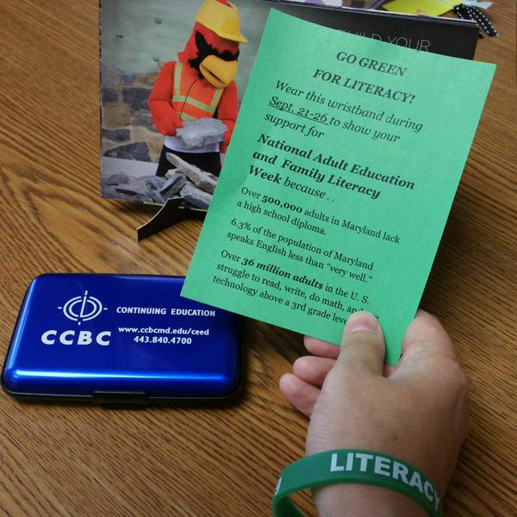
- Designate a point person from your program to coordinate your overall campaign including the social media posts, arranging for taking of photos, and recording of videos.
- Share the wristbands with adult learners, your staff, volunteers, and supporters, such as donors and local civic leaders.
- Visit your local American Job Center or workforce partner and share wristbands.
- Share wristbands and the business flyer (at www.MAACCEmd.org) with a local business.
- When you give out the wristbands, please provide the WEAR GREEN Card (PDF provided separately) MAACCE recommends printing the WEAR GREEN Card, double-sided on green paper if possible. Each sheet produces four GO GREEN Cards.
- Encourage wristband wearers to tell others why they are wearing the wristbands. Please encourage adult learners to share their personal perspectives and experiences.
- Invite a local elected official, college president, department dean, principal, director, or other staff/volunteer leader in your organization to visit a class in session and present everyone with green wristbands, and post on social media. Local officials can include your congressional representatives, county executives, and mayors.
- Ask your organization’s PR department to support your GO GREEN efforts. (Don’t forget to give your PR person a wristband!)
- MAACCE asks that each program send at least three photos of people (such as learners, staff, volunteers, and supporters) wearing the wristbands with a description. Please email photos to maacce@gmail.com. MAACCE will be posting photos on our Facebook page and Twitter feed and linking these to national organizations’ posting sites.
- MAACCE would like photos of adult learners. If you need to obtain media releases from your learners, please the sample release provided in this kit or your organization’s media release. Designate a point person to obtain the releases, scan them, and email them to maacce@gmail.com. (As a last resort, without media releases, you can just show hands or not show faces, BUT faces are so much better!)
- Expand your GO GREEN efforts by implementing some of the General Go Green Ideas on the next page!
- Post photos of your GO GREEN efforts, especially with the wristbands, on your Facebook page or Twitter feed and print and post on bulletin boards. Please use these #InvestInMarylandAdultedu, #MAACCEgreen, and #AEFLWeek if possible, so that others can find your posts on Facebook and Twitter!
- As another green effort, please save whatever wristbands you have left over at the end of September, so they can be used in the future.
- Please consider a donation of $10 (or more) to MAACCE to help us cover this expense. (We are providing thousands of wristbands across the state!)

GENERAL GO GREEN FOR LITERACY TIPS
In this campaign, we really want people to see GREEN as MAACCE members GO GREEN for LITERACY. Here are some ideas:
- Dress in green shirts, pants, scarves, socks, shoes, and ties!
- Wear green nail polish!
- Tie together a green ribbon and wear it on your lapel.
- Wear a green ribbon in your hair—or spray it green.
- Decorate your classrooms and offices in green.
- Put out bowls of green candies in your offices and classrooms!
- Create a poster with the words “GO GREEN for LITERACY” and take a group photo.
- Feature pictures of learners and staff wearing green when you post your GO GREEN efforts on your Facebook page or Twitter feed and print and post on bulletin boards. Please use #AdultEdu, #MAACCEgreen, and #AEFLWeek in your posts if possible, so that others can search in Facebook and Twitter to find your post! (Please find the Media Release form in this packet.)
- Print off the GO GREEN cards (PDF provided separately. We recommend printing the sheets double-sided on green paper. Each sheet yields four GO GREEN cards).
- Give out GO GREEN cards (with wristbands if possible) to learners, staff, supporters, workforce partners, businesses, and local political leaders.
- Print out GO GREEN cards to put in your office to give out to people who visit your office.
- Ask learners, staff, and supporters to give out GO GREEN cards to raise awareness. They can use the stats from the cards, but please encourage individuals to share their personal perspectives and experiences.)
- If your organization allows, put your email signature in green for the week and include this in your signature:

GO GREEN for LITERACY!
National Adult Education and Family Literacy Week
Sept. 23-29, 2018
www.MAACCEmd.org
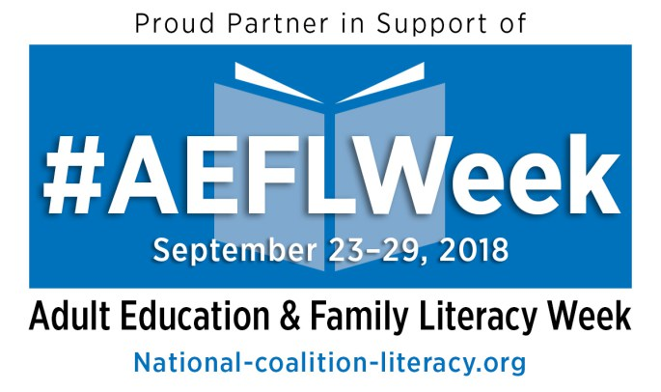

- Incorporate green in your website and social media colors for the week.
SAMPLE MEDIA RELEASE FORM
I hereby grant _______________ and Maryland Association for Adult, Continuing, and Community Education (MAACCE) permission to use my likeness in a photograph or video in any of its publications, including website or social media posts, (including but not limited to Facebook, Twitter, Instagram) without payment or any other consideration.

I hereby grant _______________ and MAACCE permission to use my written, spoken or other creative work in any of its publications, including website or social media posts, (including but not limited to Facebook, Twitter, Instagram) and printed marketing materials, without payment or any other consideration.

I understand that _______________ and MAACCE reserve the right to use my image or creative work in conjunction with any publications, including website or Facebook entries and printed marketing materials developed with or distributed by _______ or MAACCE’s partners.

I hereby irrevocably authorize _______________ and MAACCE to edit, alter, copy, exhibit, publish or distribute this photo or video for purposes of publicizing _______________ and MAACCE’s programs or for any other lawful purpose. In addition, I waive the right to inspect or approve the finished product, including written or electronic copy, wherein my likeness appears. Additionally, I waive any right to royalties or other compensation arising or related to the use of the photograph or video.

I hereby hold harmless and release and forever discharge _______________ and MAACCE from all claims, demands, and causes of action which I, my heirs, representatives, executors, administrators, or any other persons acting on my behalf or on behalf of my estate have or may have by reason of this authorization.

I am 18 years of age or older and am competent to contract in my own name. I have read this release before signing below and I fully understand the contents, meaning, and impact of this release.

Print Name:
Signature:
Date:

If the person signing is under age 18, there must be consent by a parent or guardian, as follows:
I hereby certify that I am the parent or guardian of ______________________________, named above, and do hereby give my consent without reservation to the foregoing on behalf of this person.

Print Name (parent/guardian):
Signature(parent/guardian):
Date:

TIPS FOR SHARING ADULT LEARNER SUCCESS STORIES

Top of Form
Bottom of Form
1. Write and submit written stories to MAACCE, COABE, and your local
newsletters and newspapers about learner successes, program highlights and key accomplishments. For MAACCE, please submit to maaccecoordinator@maaccemd.org. These stories can feature past graduates, current learners, or the recent work of your program. We love including these in the MAACCE Matters newsletters.

2. Prepare an inspirational video, or submit a video that you have already created about learners or program successes. Please send to
maaccecoordinator@maaccemd.org for posting on our website. (If you have trouble sending the file, please let us know and we will provide a Drobox link for you to use. You can also place these videos on your own website with information about National AEFL Week using the information from the MAACCE mini-toolkit. You can also create a simple video on a smartphone and send to us. Any video of adult learners sharing their stories will help us as we communicate with government leaders!

3. Share the stories and videos through social media. Please be sure to send to your institution’s leadership and local government officials along with the information about National AEFL Week provided in MAACCE’s mini-toolkit.

4. Share the Adult Student Action Sheet with your learners. Ask your learners for ideas to get the word out about how Maryland adult education create economic opportunities.

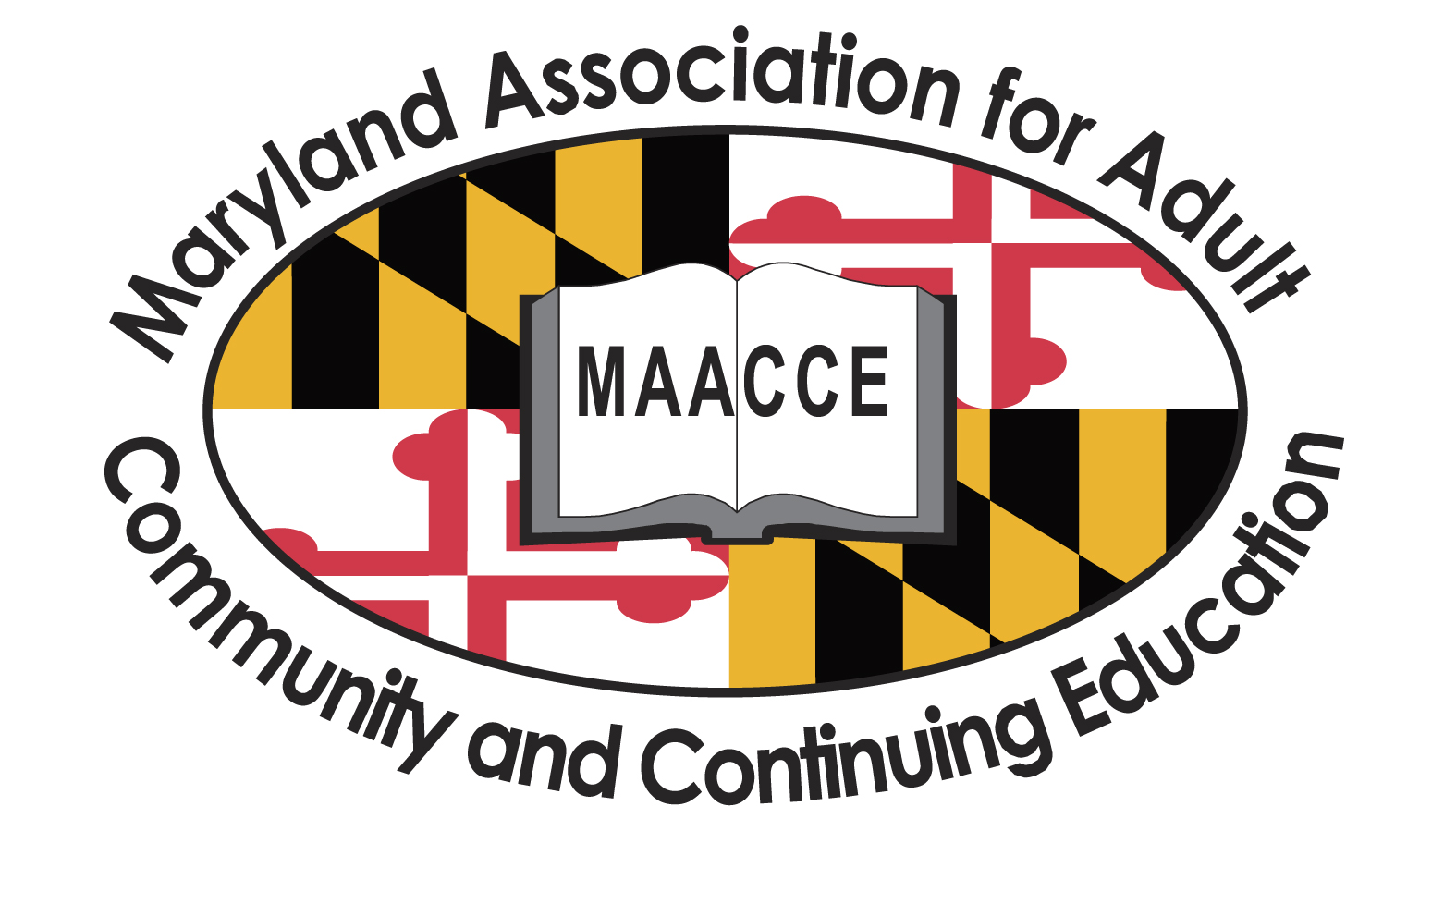
Adult Student Action Sheet
September 23-29, 2018 is Adult Education and Family Literacy Week. During this week, our organization, the Maryland Association for Adult, Community, and Continuing Education (MAACCE), tries to get more people to know about programs like yours. MAACCE is an organization to help teachers and others as they help you.

We need your help! Your voice is the most powerful tool for people to understand how important adult education is. Here are a few ideas, but if you have other ways to get the message out, please do so!

- Please work with your program to share your story at http://educateandelevate.org/success-story-submission-form/ Your story will appear on a national website and be read by leaders in Congress.
- Go to http://cqrcengage.com/coabe/home?0 or www.educateandelevate.org to send a message to your congressperson. Tell your story and ask your congressperson to invest in Adult Education.
- If you have a Facebook or other social media account, please post a photo of yourself wearing green. Please tell how your program helps you. Use #InvestInMarylandAdultedu, #MAACCEGreen and #AEFLWeek in your post.
- Send a photo of yourself wearing green to maacce@gmail.com. Tell us what program you attend and how that program helps you.
- Take a video of yourself. Say a few words about your program and your goals. Please send to maacce@gmail.com or post on your social media account.
- Help your program think of ways to let more people know about your program.
- Let other people who need classes know about your program. If they do not live near you, help them find a program at http://www.nationalliteracydirectory.org/
Most importantly, keep reaching for your goals. You are our heroes!
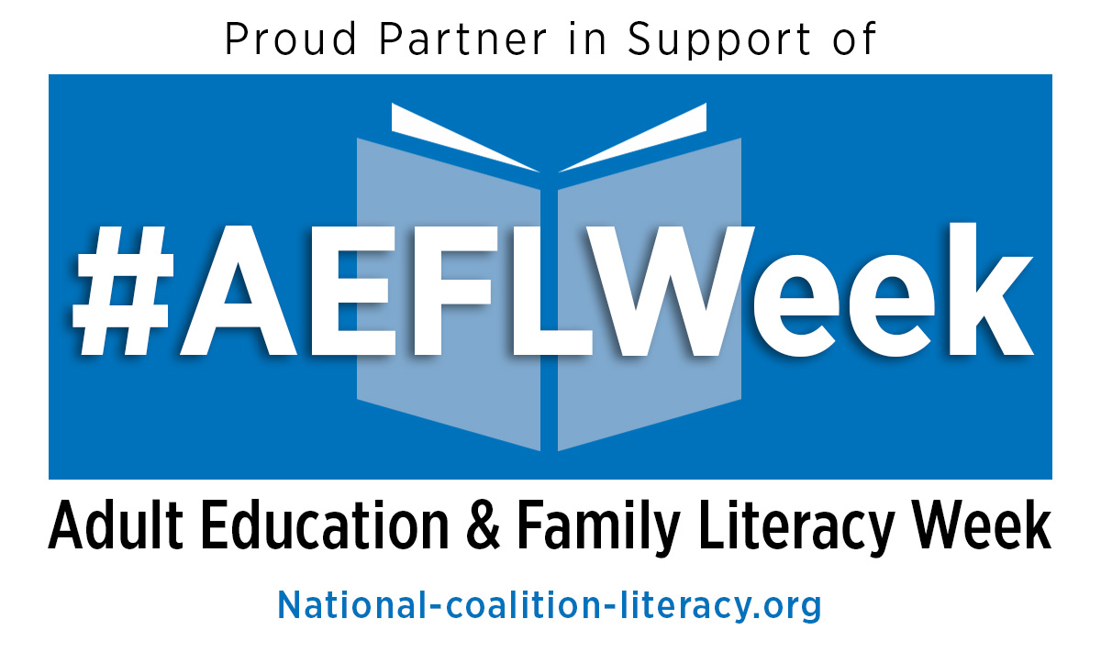

SAMPLE INTERVIEW SCRIPT FOR LEARNER VIDEOS
At MAACCE, we would be most grateful if you would take learner videos with them sharing their stories. These videos should be short- around 5 minutes. These videos will help us in our communication with state leaders and let them see faces and hear voices along with reading stats!
You can do a video on your smartphone but hold it horizontally! Your phone should record it as an mp4 format, which is best for posting online.
Here are some questions to prompt your learners in speaking. You might have them look at the questions ahead of time to plan their speaking. Adapt as needed for your program.
- What is your name and the name of the program where you take classes?

- Why did you start taking classes?

- What kind of classes are you taking?

- How have the classes (or the program) been helping you?

- What are your future goals? How is this program helping you?

SAMPLE SOCIAL MEDIA POSTS

Here are some social media posts to use during AEFL Week. They are designed to be used on LinkedIn, Facebook, and Twitter. If you wish to create your own posts, please remember that Twitter limits you to 280 characters (including spaces).

For both Facebook and Twitter, we ask that you use these #MAACCEgreen #AEFLWeek, and #InvestInMarylandAdultedu if possible. This will allow your post to show up on local and national searches and increase the possibility that others will share or retweet your post. If you have not already done so, please follow us at www.facebook.com/MAACCE and https://twitter.com/maaccemd and share or retweet our posts! MAACCE will be sharing several social media posts throughout AEFL Week!

For Facebook, you can “tag” people. If you can, please tag your own congressional representative and local political leaders.

Maryland-Specific Posts:
Over ½ million Maryland adults lack a high school diploma! #MAACCEgreen #AEFLWeek #InvestinMarylandAdultEdu

182,240 Maryland adults have less than 9th grade education #InvestinMarylandAdultEdu #MAACCEGreen #AEFLWeek

~1,452 Maryland HS diplomas earned in FY 2016 w/ GED® Test and Natnl Ext Diploma Prgrm #MAACCEGreen #InvestinMarylandAdultEdu #AEFLWeek

5% of Marylanders speak English less than “very well” #MAACCEgreen #AEFLWeek #InvestinMarylandAdultEdu

Est number Maryland adults needing Adult Education & Literacy Services = 750,000–810,000 #MAACCEgreen #AEFLWeek #InvestinMarylandAdultEdu

Approx 3,389 Maryland adults on waiting lists for literacy services #MAACCEgreen #AEFLWeek #InvestinMarylandAdultEdu

Maryland #AdultEdu students: 39% Adult Basic Education (preliterate to 8th grade skills.) #MAACCEgreen #AEFLWeek #InvestinMarylandAdultEdu

Maryland #AdultEdu students: 51% English Language Learners #MAACCEgreen #AEFLWeek #InvestinMarylandAdultEdu

Find out more about Maryland #AdultEdu http://educateandelevate.org/Maryland/ #MAACCEgreen #AEFLWeek #InvestinMarylandAdultEdu

MAACCE supports teachers and staff who serve #Adultedu learners. www.MAACCEmd.org #MAACCEgreen #AEFLWeek #InvestinMarylandAdultEdu

Find Maryland #AdultEdu programs at www.nationalliteracydirectory.org
and www.dllr.state.md.us/gedmd/programs.shtml
#InvestinMarylandAdultEdu

General Posts:
Over 55K #adultedu leaders unite to educate US about the importance of Adult Education #EducateandElevate ##AEFLWeek #MAACCEgreen

Adults with 100 hrs+ of #AdultEdu make ~$10K more in annual income. www.proliteracy.org/Resources/Need-for-Literacy-Research. #AEFLWeek

Reading, math, and computer skills strongly correlated w/ salary and job tenure. #MAACCEgreen #AEFLWeek

70% of adult welfare recipients have low literacy levels #MAACCEgreen #AEFLWeek

75% of state prison inmates are low literacy or have not completed a high school equivalency #MAACCEgreen #AEFLWeek

Employment rate for US High School dropouts is 53% but 68% for High School grads and nearly 78% for AA grads. #MAACCEgreen #AEFLWeek

Women w/ low literacy: 2 times likely as men to earn less than $300 a week. #AEFLWeek #EducateandElevate #MAACCEGreen

Minimum wage workers increased wages by 18 to 25$ within 18 months of exiting #adultedu program. #AEFLWeek #AdultEdu #MAACCEGreen

Better educated parents tend to produce better educated children. #EducateandElevate #AEFLWeek #MAACCEGreen

#HealthLit programs can increase adults' understanding of medical problems & save medical costs. #AEFLWeek #MAACCEGreen

Literacy education in adulthood is an important contributor to child success in pre-school. #AEFLWeek #FamLit #MAACCEGreen

Over 36M US adults struggle to read, write, do math, and use technology above a 3rd grade level. #AEFLWeek #MAACCEGreen

Low literacy adds an estimated $230 billion to the country's annual healthcare costs. #AEFLWeek #AdultEdu #MAACCEGreen

People with low skills—4 times more likely to have poor health (twice the national average). #AEFLWeek #AdultEdu #MAACCEGreen

People from low educated families are 10 times more likely to have low literacy skills. #AEFLWeek #AdultEdu #MAACCEGreen

Special thanks go to the MAACCE Advocacy Committee for putting together this mini-kit.

MAACCE thanks the National Coalition for Literacy for their leadership in Adult Education and Family Literacy Week!

MAACCE is happy to be a

