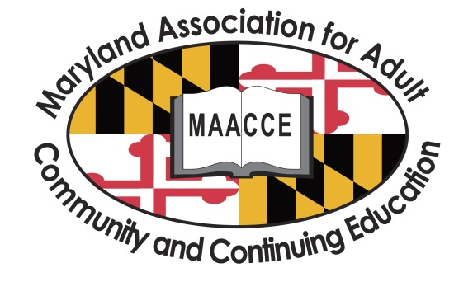
National Adult Education and Family Literacy Week 2015
Mini-Toolkit

This mini-toolkit provides a number of suggested activities that you can do during National Adult Education and Family Literacy Week to raise awareness about adult literacy and to celebrate our adult learners’ successes! Please do not feel like you have to do every activity; choose 3-4 that are right for you!
On the following pages, you will find the following:
- Tips/Instructions for using the literacy wristbands to promote MAACCE’s GO GREEN for Adult Literacy Awareness Campaign
- General GO GREEN for LITERACY Ideas
- Sample Media Release Form
- Tips for sharing adult learner success stories
- Sample letter to the editor to adapt for your local newspaper, highlighting your local program’s role in serving adult learners
- Sample social media posts that you can use with Facebook and Twitter

MAACCE thanks Cynthia Campbell, EdD, and Sonia Socha, MS Education, of Gold Apple Services for their work on the GO GREEN for LITERACY Campaign. www.GoldAppleServices.com
TIPS/INSTRUCTIONS FOR USING
THE GO GREEN FOR LITERACY WRISTBANDS
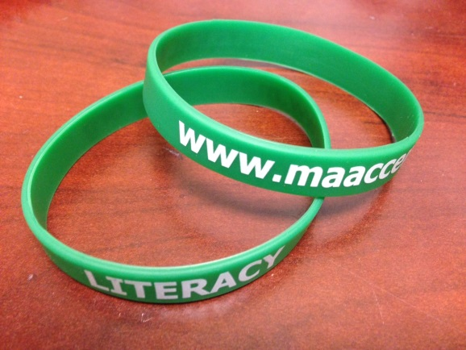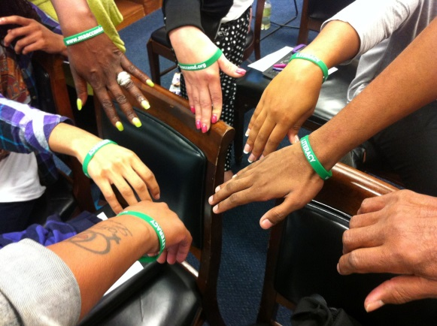
- Designate a point person from your program to coordinate your overall campaign including the social media posts, arranging for photos to be taken, and stories to be written.
- Share the wristbands with adult learners, your staff, volunteers, and supporters, such as donors and local civic leaders.
- When you give out the wristbands, please provide the GO GREEN Wristband Card (See PDF, which came with this kit.) MAACCE recommends printing the GO GREEN Wristband Card sheet, double-sided on green paper if possible. Each sheet produces four GO GREEN Wristband Cards.
- Encourage wristband wearers to tell others why they are wearing the wristbands. (The Wristband Card has some stats that people can share, and also please encourage individuals to share their personal perspectives and experiences.)
- Invite a local elected official, college president, department dean, principal, director, or other staff/volunteer leader in your organization to visit a class in session and present everyone with green wristbands, and post on social media.
- Ask your organization’s PR department to support your GO GREEN efforts. (Don’t forget to give your PR person a wristband!)
- For every 50 wristbands that you receive from MAACCE, please send us one photo of people (such as learners, staff, volunteers, and supporters) wearing the wristbands with a description. Please email photos to maacce@gmail.com. MAACCE will be posting photos on our Facebook page and Twitter feed and linking these to national organizations’ posting sites.
- MAACCE would like photos of adult learners. If you need to obtain media releases from your learners, we recommend using the sample release provided in this kit or your organization’s media release. Designate a point person to obtain the releases. (As a last resort, without media releases, you can just show hands, like the photo above, or not show faces, BUT faces would be optimal!)
- Expand your GO GREEN efforts by implementing some of the General Go Green Ideas on the next page!
- Post photos of your GO GREEN efforts, especially with the wristbands, on your Facebook page or Twitter feed and print and post on bulletin boards. Please use these #AdultEdu, #MAACCEgreen, and #AEFLWeek if possible, so that others can search in Facebook and Twitter to find your post!
- As another green effort, please save whatever wristbands you have left over at the end of September, so they can be used next year. MAACCE requests that you return unused bands to the MAACCE Coordinator by October 10. See the address on the website.
- Programs that received more than 100 bands are asked to consider a donation of $10-$50 to MAACCE to help us cover this expense. (We are providing over 6,000 wristbands across the state!)

GENERAL GO GREEN FOR LITERACY IDEAS
In this campaign, we really want people to see GREEN as MAACCE members GO GREEN for LITERACY. Here are some ideas:

- Designate a point person from your program to coordinate your overall campaign including the social media posts, arranging for photos to be taken, and stories to be written.
- Dress in green shirts, pants, scarves, socks, shoes, and ties!
- Wear green nail polish!
- Tie together a green ribbon and wear it on your lapel.
- Wear a green ribbon in your hair—or spray it green.
- Decorate your classrooms and offices in green.
- Put out bowls of green candies in your offices and classrooms!
- Create a poster with the words “GO GREEN for LITERACY” and take a group photo.
- Feature pictures of learners and staff wearing green when you post your GO GREEN efforts on your Facebook page or Twitter feed and print and post on bulletin boards. Please use #AdultEdu, #MAACCEgreen, and #AEFLWeek in your posts if possible, so that others can search in Facebook and Twitter to find your post! (If you need a media release form, there is one in this packet.)
- Print off the GO GREEN cards (See attached PDF. We recommend printing the sheets on green paper and double-sided. Each sheet yields four GO GREEN cards).
- Give out GO GREEN to learners, staff, and supporters.
- Print out GO GREEN cards to put in your office to give out to people who visit your office.
- Ask learners, staff, and supporters to give out GO GREEN cards to raise awareness. They can use the stats from the cards, but please encourage individuals to share their personal perspectives and experiences.)
- If your organization allows, put your email signature in green for the week and include this in your signature:
GO GREEN for LITERACY
National Adult Education and Family Literacy Week
Sept. 21-26, 2015
www.MAACCEmd.org

- Incorporate green in your website and social media colors for the week.
SAMPLE MEDIA RELEASE FORM
I hereby grant _______________ and Maryland Association for Adult, Continuing, and Community Education (MAACCE) permission to use my likeness in a photograph or video in any of its publications, including website or social media posts, (including but not limited to Facebook, Twitter, Instagram) without payment or any other consideration.

I hereby grant _______________ and MAACCE permission to use my written, spoken or other creative work in any of its publications, including website or social media posts, (including but not limited to Facebook, Twitter, Instagram) and printed marketing materials, without payment or any other consideration.

I understand that _______________ and MAACCE reserve the right to use my image or creative work in conjunction with any publications, including website or Facebook entries and printed marketing materials developed with or distributed by _______ or MAACCE’s partners.

I hereby irrevocably authorize _______________ and MAACCE to edit, alter, copy, exhibit, publish or distribute this photo or video for purposes of publicizing _______________ and MAACCE’s programs or for any other lawful purpose. In addition, I waive the right to inspect or approve the finished product, including written or electronic copy, wherein my likeness appears. Additionally, I waive any right to royalties or other compensation arising or related to the use of the photograph or video.

I hereby hold harmless and release and forever discharge _______________ and MAACCE from all claims, demands, and causes of action which I, my heirs, representatives, executors, administrators, or any other persons acting on my behalf or on behalf of my estate have or may have by reason of this authorization.

I am 18 years of age or older and am competent to contract in my own name. I have read this release before signing below and I fully understand the contents, meaning, and impact of this release.

Print Name:
Signature:
Date:

If the person signing is under age 18, there must be consent by a parent or guardian, as follows:
I hereby certify that I am the parent or guardian of ______________________________, named above, and do hereby give my consent without reservation to the foregoing on behalf of this person.

Print Name (parent/guardian):
Signature(parent/guardian):
Date:

TIPS FOR SHARING ADULT LEARNER SUCCESS STORIES

Top of Form
Bottom of Form
1. Write and submit written stories to MAACCE, COABE, and your local
newsletters and newspapers about learner successes, program highlights and key accomplishments. For MAACCE, please submit to maacce@gmail.com. These stories can feature past graduates, current learners, or the recent work of your program.

2. Prepare an inspirational video, or submit a video that you have already created about learners or program successes. Please send to
maacce@gmail.com for posting on our website and we will also post with national organizations. You can also place these videos on your own website with information about National AEFL Week utilizing the information provided in the MAACCE mini-toolkit.

3. Share the stories and videos through social media. Please be sure to send to your institution’s leadership and local government officials along with the information about National AEFL Week provided in MAACCE’s mini-toolkit.

SAMPLE LETTER TO THE EDITOR
PLEASE ADAPT TO YOUR LOCAL AREA
(You can submit a letter to the editor as a representative of your organization, or if your organization does not allow something “official,” you or a supporter can write a letter as an individual. Please send out by Sept 19th if possible, but if not, please send the following week)

Dear Editor:
A Silent Epidemic Affects Maryland, but You Can Help!
If you knew that nearly 800,000 Maryland adults are unable to obtain employment, access job training, understand medicine labels, help their children with homework, or read to them, would you call that a crisis? Low literacy among adults tends to be invisible to many of us, but in the United States, more than 36 million American adults struggle to read, write, do math, and use technology above a third grade level.

In Maryland alone, over 500,000 adults lack a high school diploma, which means they are ineligible for many jobs and most job training programs. Many immigrants desire to learn English, but find few opportunities. Over 6% of Marylanders speak English less than very well. Alarmingly, more than 8,000 Maryland adults languish on waiting lists across the state for educational services.

From 2002-2012, adjusted for inflation and related to sequestration, federal funding for adult education has gone down 17%. The National Adult Education and Family Literacy Week (NAEFLW), from September 21-26, is an annual effort to increase the public’s understanding of the need to support adult literacy, increase federal funding and leverage local funds. Increased funding will expand the capacity to serve educationally disadvantaged adults as they work to increase their basic skills, earn a high school diploma, become employable, and improve their lives and that of their families.

To celebrate NAEFLW, the Maryland Association for Adult, Community and Continuing Education (MAACCE) is presenting its first statewide awareness campaign, GO GREEN for LITERACY. MAACCE, a professional membership organization of over 400, will be asking its members, adult learners, program staff, and supporters, to wear green wristbands and green clothing as part of highlighting the continuing need to support adult literacy education. Programs will also be featuring learners’ key successes and their inspirational stories.

In (insert your county or city’s name), one program serving adult learners is (Insert program name). (Provide a 2to 3 sentence description, including local stats describing the need in the county/city.)

September 25 is Adult Literacy Day of Giving. On that day, you can help by making a generous donation to a local adult education provider. You can find an adult education provider in your area at www.maaccemd.org/directory-of-md-adult-education-programs, or you can donate to MAACCE at www.maaccemd.org to help with providing professional development to adult education staff.

You can also help by volunteering for a local program or donating school supplies or appropriate books to a local program. If you know individuals who need adult literacy services, you can refer them to the Maryland Literacy Hotline at 410-752-3595 or to a program you find in the directory at the MAACCE website.

Every effort counts and you can make a difference in adult learners’ lives!

Sincerely,
Name
Contact Information

SAMPLE SOCIAL MEDIA POSTS

Here are some social media posts that you can use during AEFL Week. They are designed to be used both on Facebook and Twitter. If you wish to create your own posts, please remember that Twitter limits you to 140 characters (including spaces) and fewer if you post a photo.

For both Facebook and Twitter, we ask that you use these #MAACCEgreen #AEFLWeek, and #AdultEdu if possible. This will allow your post to show up on local and national searches and increase the possibility that the post will be share or retweeted. If you have not already done so, please follow us at www.facebook.com/MAACCE and https://twitter.com/maaccemd and share or retweet our posts! MAACCE will be sharing several social media posts throughout AEFL Week!

For Facebook, you can “tag” people. If you wish, please tag the following people: www.facebook.com/larryhoganmd, www.facebook.com/senatorbencardin, and www.facebook.com/SenatorMikulski when you post. Also, MAACCE encourages you to tag your own congressional representative and local political leaders.

Maryland-Specific Posts:

Over 500,000 Maryland adults lack a high school diploma! #MAACCEgreen #AEFLWeek

6.3% of Marylanders speaks English less than “very well” #MAACCEgreen #AEFLWeek

Est. number Maryland adults needing Adult Education & Literacy Services = 750,000–810,000 #MAACCEgreen #AEFLWeek #adultedu

Approx. 8,000 Maryland adults remain on waiting lists for literacy services #MAACCEgreen #AEFLWeek #adultedu

Maryland #AdultEdu students: 45% Adult Basic Education (from preliterate to 8th grade level equivalent) #MAACCEgreen #AEFLWeek

Maryland #AdultEdu students: 49% English Language Learners #MAACCEgreen #AEFLWeek

National Impact:
From COABE - Dr. Tom Sticht’s ABCs of Adult Literacy

Better educated parents tend to produce better educated children. #COABE #AEFLWeek #FamLit #MAACCEGreen

Globalization means USA adults must compete globally; workplace literacy programs help them compete #COABE #AEFLWeek #wkdev #MAACCEGreen

#HealthLit programs can increase adults' understanding of medical problems & save medical costs. #COABE #AEFLWeek #MAACCEGreen

Literacy education in adulthood is an important contributor to child success in pre-school. #COABE #AEFLWeek #FamLit #MAACCEGreen

From ProLiteracy
Over 36 million US adults struggle to read, write, do math, and use technology above a 3rd grade level. #AEFLWeek #AdultEdu #MAACCEGreen

Women with low literacy are twice as likely as men to earn less than $300 a week. #AEFLWeek #AdultEdu #MAACCEGreen

Minimum wage workers increased wages by 18 to 25$ within 18 months of exiting an #adultedu program. #AEFLWeek #AdultEdu #MAACCEGreen

Low literacy adds an estimated $230 billion to the country's annual healthcare costs. #AEFLWeek #AdultEdu #MAACCEGreen

People with low skills are 4 times more likely to have poor health (twice the national average). #AEFLWeek #AdultEdu #MAACCEGreen

People from low educated families are 10 times more likely to have low literacy skills. #AEFLWeek #AdultEdu #MAACCEGreen

